## EXPERIMENTNO.1

INSTALLINGANDRUNNINGAPPLICATIONSONANDROIDSTUDIO

## Step1-SystemRequirements

The required tools to develop Android applications are open source and can be downloaded fromthe Web. Following is the list of software's you will need before you start your Android applicationprogramming.

JavaJDK5 or later version

Java Runtime Environment (JRE) 6AndroidStudio

## Step2-SetupAndroidStudio

Android Studio is the official IDE for android application development.It works based on IntelliJIDEA, You can download the latest version of android studio from [Android Studio 2.2 Download,](https://developer.android.com/sdk/index.html) If you are new to installing Android Studio on windows, you will find a file, which is named as android-studio-bundle-143.3101438-windows.exe.Sojustdownloadandrunonwindowsmachineaccording to android studio wizard guideline.

If you are installing Android StudioonMacorLinux,Youcandownloadthelatestversionfrom [Android Studio Mac Download,](https://dl.google.com/dl/android/studio/install/1.1.0/android-studio-ide-135.1740770-mac.dmg)or[Android Studio Linux Download,](https://dl.google.com/dl/android/studio/ide-zips/1.1.0/android-studio-ide-135.1740770-linux.zip) check the instructionsprovided along with the downloaded file for Mac OS and Linux. This tutorial will consider that youare going to setup your environment on Windows machine having Windows 8.1 operating system.Installation

So let's launch Android Studio.exe,Make sure before launch Android Studio, Our Machine shouldrequired installedJavaJDK.To installJavaJDK, take areferencesof[Androidenvironmentsetup](https://www.tutorialspoint.com/android/android_environment_setup.htm)

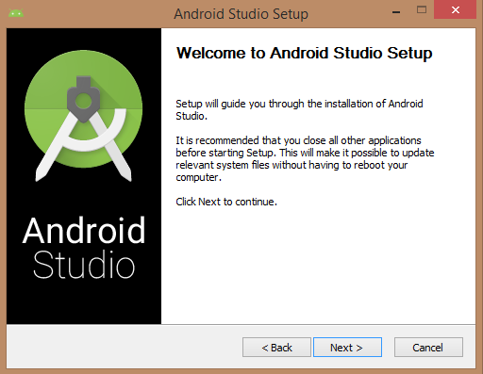

OnceyoulaunchedAndroidStudio, itstimetomentionJDK7pathorlaterversioninandroidstudioinstaller.

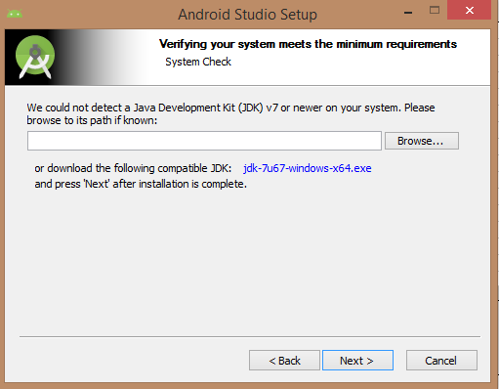

BelowtheimageinitiatingJDKtoandroidSDK

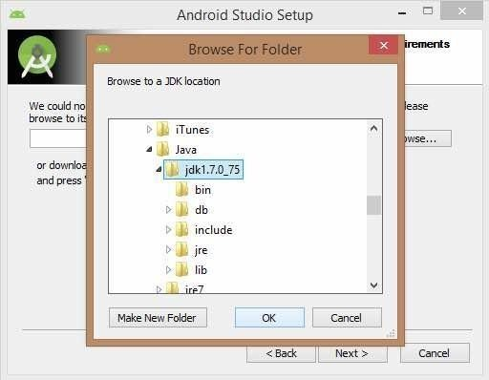

Needtocheckthecomponents,whicharerequiredtocreateapplications,belowtheimagehasselectedAndroidStudio,AndroidSDK,AndroidVirtualMachineand performance(Intelchip).

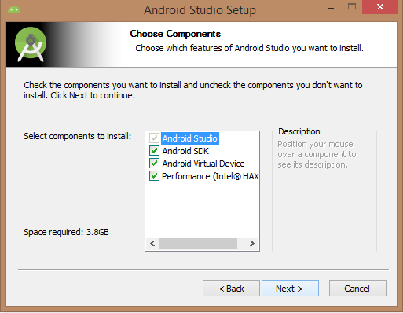

Needtospecifythelocationoflocalmachinepath forAndroidstudioandAndroidSDK,belowtheimagehas takendefaultlocationofwindows8.1x64bit architecture.

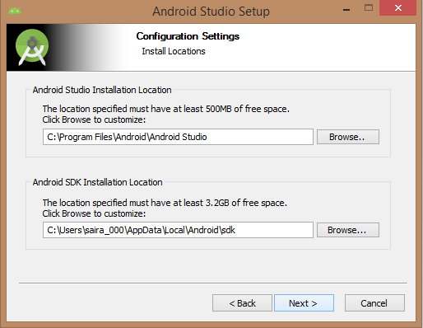

NeedtospecifytheramspaceforAndroidemulatorbydefaultitwouldtake512MB of localmachineRAM.

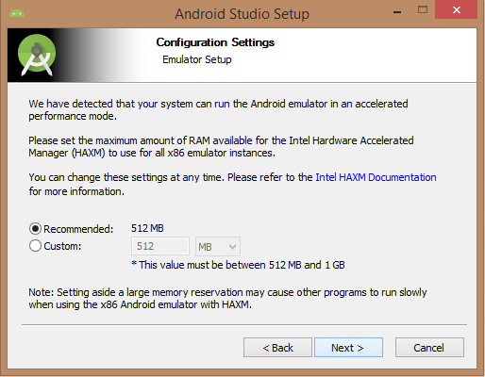

Atfinalstage,itwouldextractSDKpackagesintoourlocalmachine,itwouldtakeawhiletimetofinish the task andwouldtake 2626MBofHarddisk space.

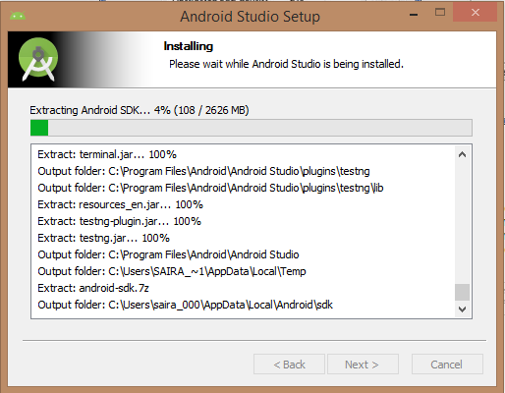

Afterdoneallabovestepsperfectly,youmustgetfinishbuttonand itgonnabeopenandroidstudioproject withWelcome toandroidstudiomessageasshownbelow

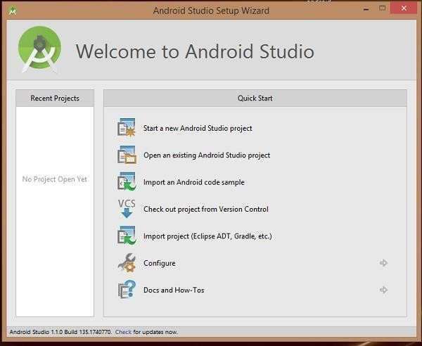

Youcanstartyourapplicationdevelopmentbycallingstartanewandroidstudioproject.inanewinstallationframeshouldaskApplicationname,packageinformationandlocationoftheproject.

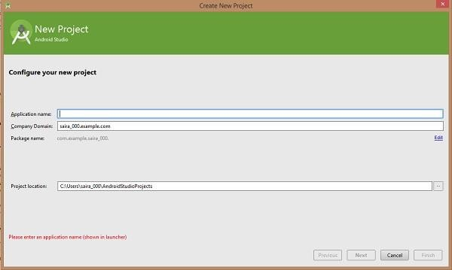

Afterenteredapplicationname,itgoingtobecalledselecttheformfactorsyourapplicationrunson, here need to specify Minimum SDK, in our tutorial, I have declared as API23: Android6.0(Mashmallow)

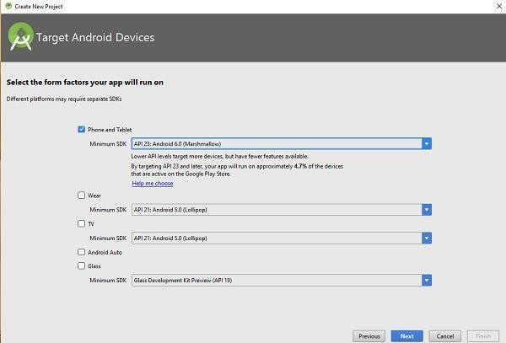

Thenextlevelofinstallationshouldcontainselectingtheactivitytomobile,itspecifiesthedefaultlayoutforApplications

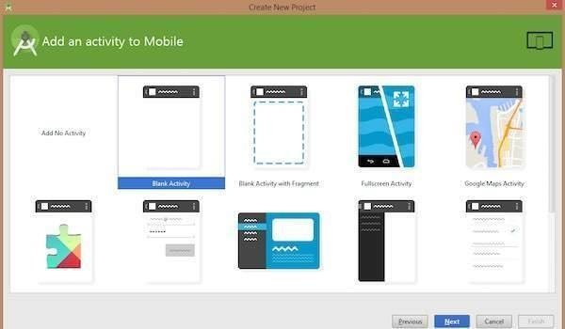

Atthefinalstageitgoing tobeopen developmenttooltowritetheapplicationcode.

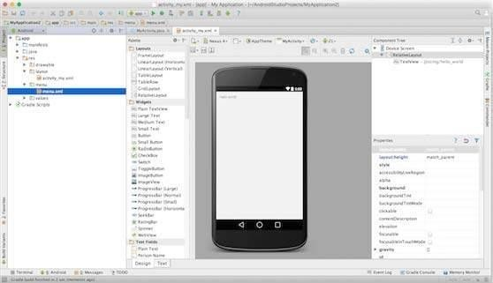

Step3-CreateAndroidVirtualDevice

To test your Android applications, you will need a virtual Android device. So before we startwritingourcode,letuscreateanAndroidvirtualdevice.LaunchAndroidAVDManagerClickingAVD_Managericonas shownbelow

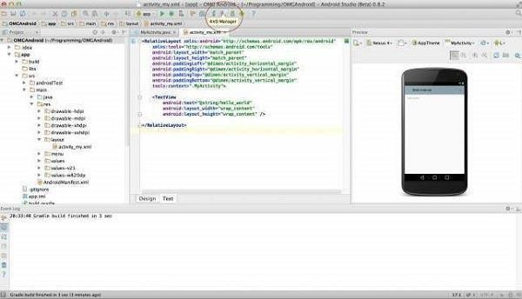

AfterClickonavirtualdeviceicon,itgoingtobeshownbydefaultvirtualdeviceswhicharepresent on your SDK, or else need to create a virtual device by clicking Create new Virtualdevicebutton

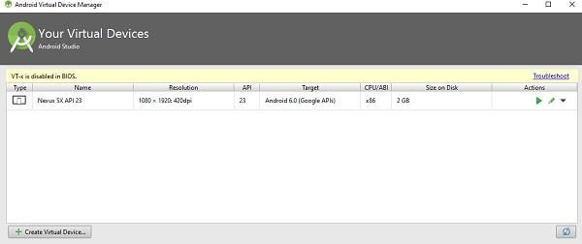

If your AVD is created successfully it means your environment is ready for Android applicationdevelopment. If you like, you can close this window using top-right cross button. Better you re-start your machine and once you are done with this last step, you are ready to proceed for yourfirst Android example but before that we will see few more important concepts related to AndroidApplication Development.